**INDEX**

|  |  |  |
| --- | --- | --- |
| **S.NO** | **TITLE** | **PAGE.NO** |
| **1.** | **INTRODUCTION**   * 1. Overview   2. Purpose |  |
| **2.** | **PROBLEM DEFENITION & DESIGN THINKING**  2.1 Empathy Map  2.2 Ideation & Brainstorming Map |  |
| **3.** | **RESULT** |  |
| **4.** | **ADVANTAGES & DISADVANTAGES** |  |
| **5.** | **APPLICATIONS** |  |
| **6.** | **CONCLUSION** |  |
| **7.** | **FUTURE SCOPE** |  |
| **8.** | **APPENDIX**  **A)** Source Code |  |

CHRONIC KIDNEY DISEASE

1.INTRODUCT ION

Chronic kidney disease (CKD) is non-communicable disease that has significantly contributed to morbidity, mortality and admission rate of patients worldwide . It is quickly expanding and becoming one of the major causes of death all over the world. A report from indicated that the global yearly life loss caused by CKD increased by and it is the leading cause of death in the world . people throughout the world are likely to have kidney diseases from different factor. Its burden is even higher in low-income countries where detection, prevention and treatment remain low Kidney disease is serious public health problem in Ethiopia effecting hundreds of thousands of people irrespective of age, sex . The lack of safe water, appropriate diet, and physical activities is believed have contributed. Additionally, communities living in rural area have limited knowledge about the CKD.

National kidney foundation classifies stages of CKD into five based on the abnormal kidney function and reduced, a symptoms and is considered as end-stage or kidney failure. The Renal Replacement Therapy (RRT) cost for total kidney failure is very expensive. The treatment is not also available in most developing countries like Ethiopia. As a result, the management of kidney failure and its complications is very difficult in developing countries due to shortage of facilities, physicians, and the high cost to get the treatment . Hence, early detection of CKD is very essential to minimize the economic burden and maximize the effectiveness of treatments. Predictive analysis using machine learning techniques can be helpful through an early detection of CKD for efficient and timely interventions . In this study, Random Forest (RF), Support Vector Machine (SVM) and Decision Tree (DT) have been used to detect CKD. Most of previous researches focused on two classes, which make treatment recommendations difficult because the type of treatment to be given is based on the severity of CKD.

1.1 Overview

CKD is a condition in which the kidneys are damaged and cannot filter blood as well as they should. Because of this, excess fluid and waste from blood remain in the body and may cause other health problems, such as heart disease and stroke.

Some other health consequences of CKD include:

* Anemia or low number of red blood cells
* Increased occurrence of infections
* Low calcium levels, high potassium levels, and high phosphorus levels in the blood
* Loss of appetite or eating less
* Depression or lower quality of life

CKD has varying levels of seriousness. It usually gets worse over time though treatment has been shown to slow progression. If left untreated, CKD can progress to kidney failure and early cardiovascular disease. When the kidneys stop working, [dialysis](https://www.cdc.gov/dialysis/) or kidney transplant is needed for survival. Kidney failure treated with dialysis or kidney transplant is called end-stage renal disease (ESRD).

1.2Purpose

The kidneys are two bean-shaped organs. Each kidney is about the size of a fist. Your kidneys filter extra water and wastes out of your blood and make urine. Kidney disease means your kidneys are damaged and can’t filter blood the way they should.You are at greater risk for kidney disease if you have diabetes or high blood pressure. If you experience kidney failure, treatments includekidney transplant or dialysis. Other kidney problems include acute kidney injury, kidney cysts, kidney stones, and kidney infections.

2.PROBLEM DEFINITION & DESIGN THINKING

2.1 Empathy Map

|  |  |
| --- | --- |
| TeamID | NM2023TMID32910 |
| ProjectName | Identifying Patterns and Trends in campusplacementdatausingmachinelearningwith  Python |
| MaximumMarks | 5Marks |

Chronic kidney disease(ckd) is a major medical problem and can be cured if treated in the early stage.usually,people are not aware that medical tests we take for different purpose could contain valuable information concerning kidney diseases, consequently, attributes of various medical tests are inverstigated to distinguish which attributes may contain helpful information about the disease.The information says that it helps us to measure the severity of the problem, the predicted survival of the patient after the lilness,the pattern of the disease and work for curing the disease.

In todays world as we know most of the people are facing so may disease and as this can be cured if we treat people in early stages this project can use a pretrained model to predict the Chronic Kidney Disease which can help in treatments of people who are suffer from this disease.

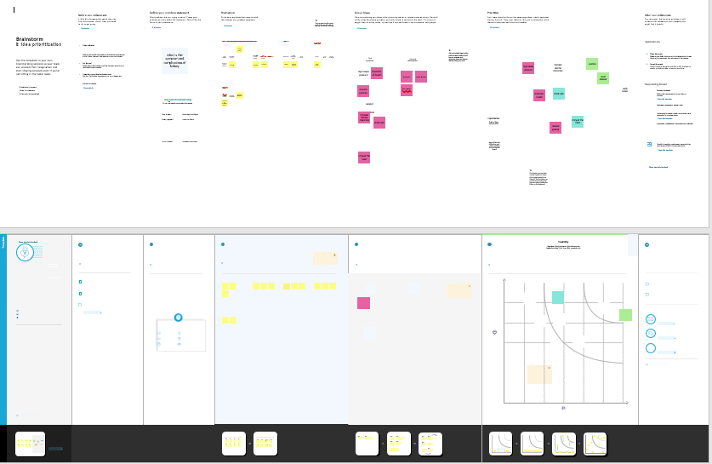

2.2 Brainstorming Map

|  |  |
| --- | --- |
| TeamID | NM2023TMID32910 |
| ProjectName | Identifying Patterns and Trends in campusplacementdatausingmachinelearningwith  Python |
| MaximumMarks | 5Marks |

Chronic kidney disease(ckd) is a major medical problem and can be cured if treated in the early stage.usually,people are not aware that medical tests we take for different purpose could contain valuable information concerning kidney diseases, consequently, attributes of various medical tests are inverstigated to distinguish which attributes may contain helpful information about the disease.The information says that it helps us to measure the severity of the problem, the predicted survival of the patient after the lilness,the pattern of the disease and work for curing the disease.

In todays world as we know most of the people are facing so may disease and as this can be cured if we treat people in early stages this project can use a pretrained model to predict the Chronic Kidney Disease which can help in treatments of people who are suffer from this disease.

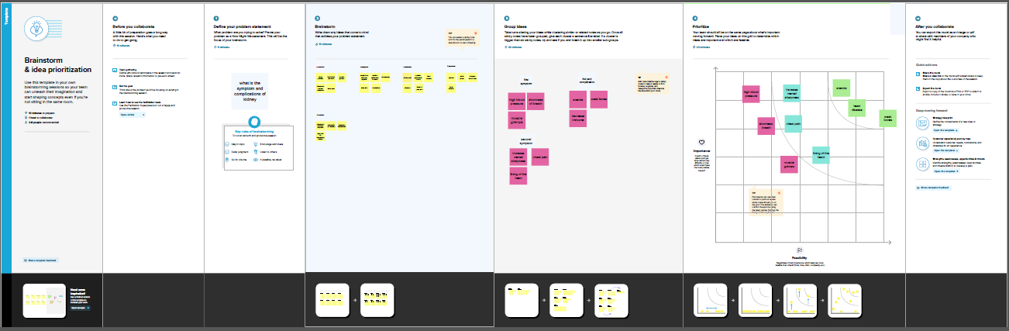

RESULT

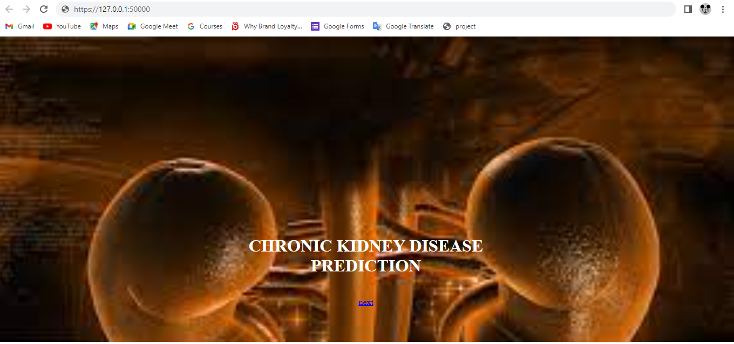

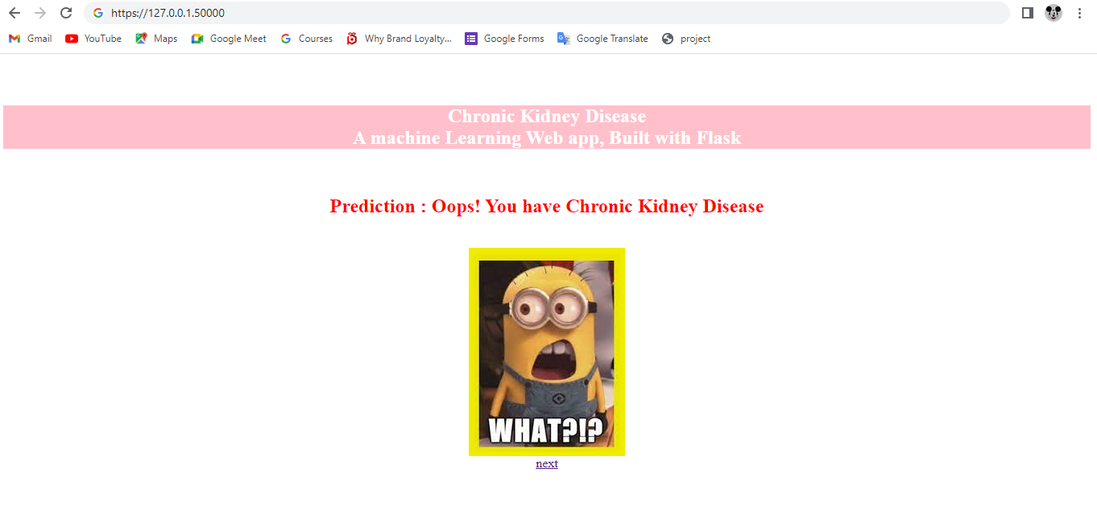

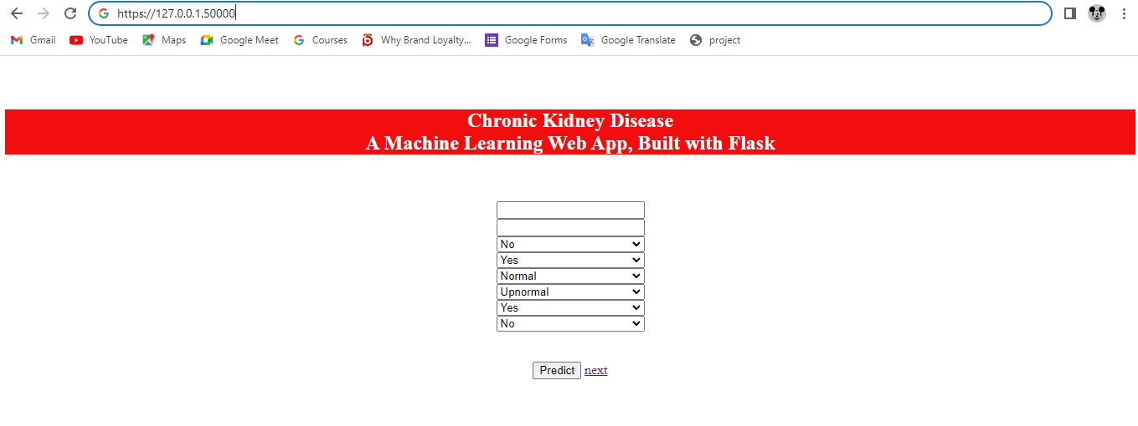

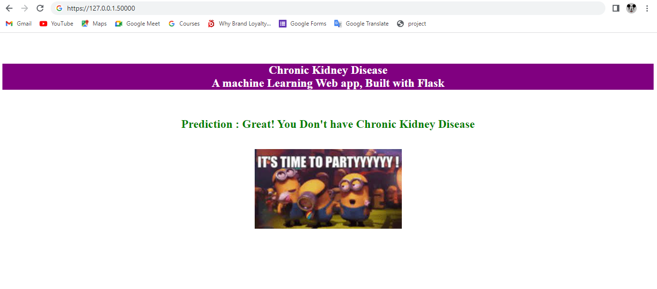

4. ADVANTAGES

* Restoration of “normal” renal function.
* Freedom from dialysis .
* Return to “ normal” life.
* Reverses pathophysiological changes related to Renal Failure.
* Less expensive than dialysis after 1st year.

DISADVANTAGES

* Life long medications.
* Multiple side effects from medication.
* Increased risk of tumor.
* Increased risk of infection.
* Major surgery.

5. APPLICATIONS

Chronic kidney disease(CKD) is a global public health issue. Mobile technology is pervasive and widely used in chronic disease care. More and more, CKD mobile applications (apps) can be found on popular mobile application platforms, especially in Chinese. We aim to explore current mobile apps for CKD patient care through content analysis to identify the app functions that health professionals can use in CKD patients with self-management.

6.CONCLUSION

Chronic Kidney Disease is a worldwide killer that is under-diagnosed and under-treated. The increased burden of chronic kidney disease in developing countries is due to globalization, low socioeconomic status, and poor access to health care and health care disparities. By early detection, treatment increasing community outreach and access to preventive medicine for high risk population , can decrease the rising burden of CKD.

Chronic Kidney Disease develops indolently, with many patients diagnosed late and a specific cause never established in a significant number of patients. It has various multi-system complications, significantly impairing the quality of life and shortening the life span of victims. Thus the prevention and early detection of chronic kidney disease is of utmost importance.

Annual screening is recommended for patients at high risk of developing chronic kidney disease. This involves checking blood pressure, urine dipstick testing and estimating the kidney clearance function. In patients with established chronic kidney disease, kidney protective measures are indicated to arrest or slow down the loss of kidney function.

7.FUTURE SCOPE

This would help detect the chances of a person having CKD further on in his life which would. be really helpful and cost-effective people. This model could be integrated with normal blood report generation, which could. automatically flag out if there is a person at risk. Patients would not have to go to a doctor unless they are flagged by the algorithms. This would make it cheaper and easier for the modern busy person.

8.APPENDIX

A. Source code

Attach the code for the solution built

